December 10, 2025
Eulogio “Amang” Rodriguez Institute of Science and Technology (EARIST) – Manila
College of Engineering
Manila, Philippines
Subject: Notice of Internship Termination – Mr. Eruel Joseph F. Manales
Dear Sir/Madam,
Good day.
This letter is to formally notify your office that Mr. Eruel Joseph F. Manales, a Bachelor of Science in Computer Engineering student from EARIST – Manila, has had his internship program with Sadsad Tamesis Legal and Accountancy Firm (STLAF) terminated effective today.
The termination was carried out due to lack of updates, non-submission of required progress reports, and absence of any communication from Mr. Manales despite the firm’s attempts to reach him. As a result, we were unable to monitor his attendance, performance, and compliance with internship requirements.
In consideration of our firm’s operational workflow and internship standards, we deemed it necessary to end his internship engagement.
Should your office require additional details or confirmation, please feel free to contact the HR Department through our official email or phone line.
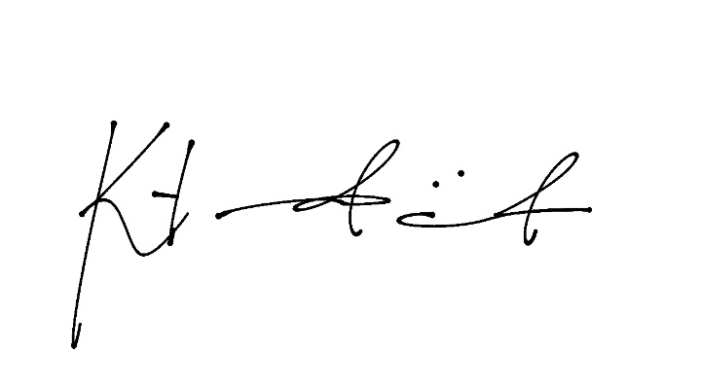
Thank you, and we appreciate your continued partnership with our firm.
Respectfully,

Katrina Pauline M. Trinidad
Head of HR Department
Sadsad Tamesis Legal and Accountancy Firm (STLAF)

